**Software Testing Assignment**

**Module – 3 (Testing on Live Application)**

1. **What is RDBMS**

* The software used to store, manage, query, and retrieve data stored in a relational database is called a relational database management system (RDBMS).
* The RDBMS provides an interface between users and applications and the database, as well as administrative functions for managing data storage, access, and performance.

1. **What is SQL**

* SQL stands for Structured Query Language.
* SQL is a standard language for storing, manipulating and retrieving data in databases. SQL allows you to access and manipulate the databases.

1. **Write SQL Commands**

[SQL](https://www.geeksforgeeks.org/sql-concepts-and-queries/) commands are mainly categorized into five categories:

1. DDL – Data Definition Language
2. DQL – Data Query Language
3. DML – Data Manipulation Language
4. DCL – Data Control Language
5. TCL – Transaction Control Language

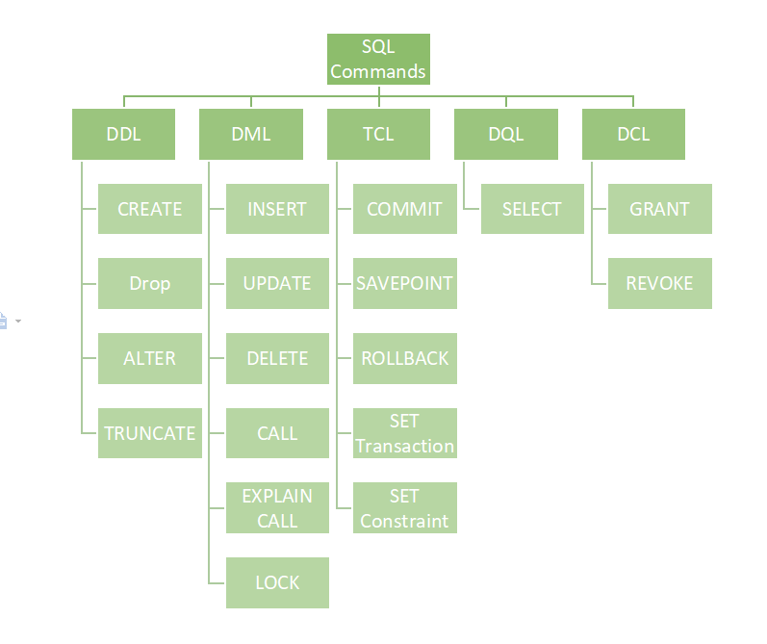

1. **What is join?**

* A JOIN clause is used to combine rows from two or more tables, based on a related column between them.
* The join keyword merges two or more tables and creates a temporary image of the merged table. Then according to the conditions provided, it extracts the required data from the image table, and once data is fetched, the temporary image of the merged tables is dumped.

1. **Write type of joins.**
2. **Inner JOIN :** The INNER JOIN keyword selects records that have matching values in both tables.
3. **Outer JOIN :** SQL Outer joins give both matched and unmatched rows of data depending on the type of outer joins.

These types are outer joins are sub-divided into the following types:

1. Left Outer Join
2. Right Outer Join
3. Full Outer Join
4. **How Many constraint and describes it self**

The following constraints are commonly used in SQL:

* 1. **NOT NULL -** Ensures that a column cannot have a NULL value
* This enforces a field to always contain a value, which means that you cannot insert a new record, or update a record without adding a value to this field.
  1. **UNIQUE - Ensures that all values in a column are different**
* UNIQUE KEY constraints provide a guarantee for uniqueness for a column or set of columns.
  1. **PRIMARY KEY - A combination of a NOT NULL and UNIQUE**
* The PRIMARY KEY constraint uniquely identifies each record in a table.
* Primary keys must contain UNIQUE values, and cannot contain NULL values.
* A table can have only ONE primary key; and in the table, this primary key can consist of single or multiple columns (fields).
  1. **FOREIGN KEY - Prevents actions that would destroy links between tables**
* The FOREIGN KEY constraint is used to prevent actions that would destroy links between tables.
* A FOREIGN KEY is a field (or collection of fields) in one table, that refers to the PRIMARY KEY in another table.
* The table with the foreign key is called the child table, and the table with the primary key is called the referenced or parent table
  1. **CHECK - Ensures that the values in a column satisfies a specific condition**
* The CHECK constraint is used to limit the value range that can be placed in a column.
* If you define a CHECK constraint on a column it will allow only certain values for this column.
* If you define a CHECK constraint on a table it can limit the values in certain columns based on values in other columns in the row.
  1. **DEFAULT - Sets a default value for a column if no value is specified**
* The DEFAULT constraint is used to set a default value for a column.
* The default value will be added to all new records, if no other value is specified.
  1. **CREATE INDEX - Used to create and retrieve data from the database very quickly**
* Indexes are used to retrieve data from the database more quickly than otherwise. The users cannot see the indexes, they are just used to speed up searches/queries.

1. **Difference between RDBMS vs DBMS**

|  |  |
| --- | --- |
| **RDBMS** | **DBMS** |
| Data stored is in table format | Data stored is in the file format |
| Multiple data elements are accessible  Together | Individual access of data elements |
| Data in the form of a table are linked together | No connection between data |
| Support distributed database | No support for distributed database |
| Data is stored in a large amount | Data stored is a small quantity |
| RDBMS supports multiple users | DBMS supports a single user |
| The software and hardware requirements are higher | The software and hardware requirements are low |
| Example: Oracle, SQL Server. | Example: XML, Microsoft Access. |

1. **What is API Testing**

* API is the mediator which helps applications to communicate with each other. It is kind of logic written by developers using any programming language to perform something.
* Testing the business logic of any application is called API. QA will test the same logic and called API testing.
* API testing is a part of back end testing like database.

1. **Types of API Testing**

There are mainly 3 types of API :

1. **Open APIs:** These types of APIs are publicly available to use like OAuth APIs from Google. It has also not given any restriction to use them. So, they are also known as Public APIs.
2. **Partner APIs:** Specific rights or licenses to access this type of API because they are not available to the public.
3. **Internal APIs:** Internal or private. These APIs are developed by companies to use in their internal systems. It helps you to enhance the productivity of your teams.
4. **What is Responsive Testing?**

* Responsive testing involves how a website or web application looks and behaves on different devices, screen sizes, and resolutions.
* The goal of responsive testing is to ensure that the website or web application can be used effectively on various devices, including desktops, laptops, tablets, and smartphones.

1. **Which types of tools are available for Responsive Testing**

Tools available for Responsive Testing**:**

* LT Browser
* Lembda Testing
* Google Resizer
* am I responsive
* Pixel tuner

1. **What is the full form of .ipa, .apk**

**.ipa :** iOS package App, international phonetic alphabet

**.apk :** Android Application Package

1. **How to create step for to open the developer option mode ON?**

**Step 1:** Go to Settings >my Phone.

**Step 2:** Tap Software Info > Build Number.

**Step 3:** Tap Build Number seven times. After the first few taps, you should see the steps counting down until you unlock the developer options. You may also have to tap in your PIN for verification.

**Step 4:** Once developer options are activated, you will see a message that reads, You are now a developer.

**Step 5:** Go back to the Settings pane, where you will now find Developer options as an entry.

**Step 6:** Tap it and toggle (USB debugging) the switch on if it is not already, and from there, you can proceed to make adjustments to your phone.

